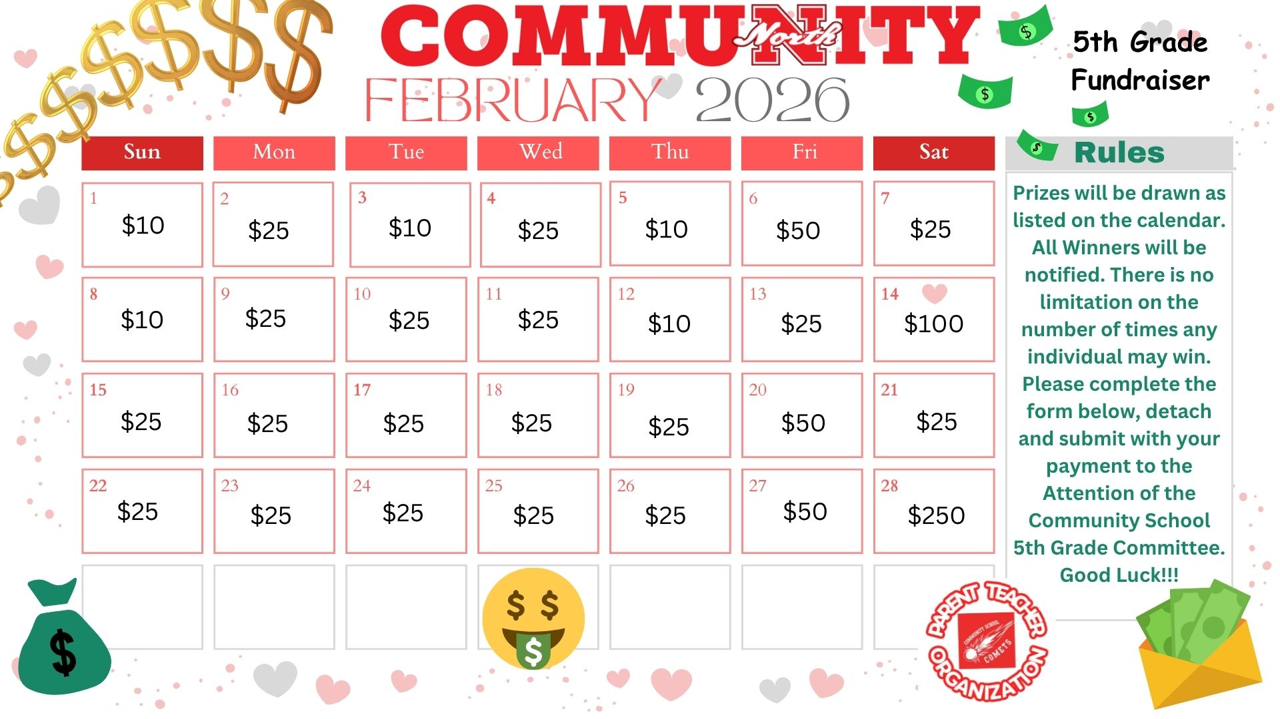
Calendars are $10 each with a chance to win up to a $1,000!
All proceeds go to support Community School 5th grade end of year activities.
Winners will be announced on Community School PTO Facebook page daily.
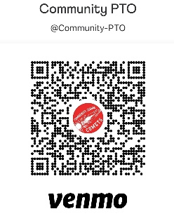
Please make checks payable to: Community School PTO.
For Venmo Payments please put Calendar in Venmo memo.
*Must be at least 18 years of age to purchase.
-------------------------------------------------------------------------------------------------------------------------------------------
Please fill out and return this section with payment to your teacher by Monday January 26, 2026.

Name: ____________________________________________________________________________
Tel #: __________________________________ Email: _____________________________________
Student: ______________________________Teacher_____________________________________

